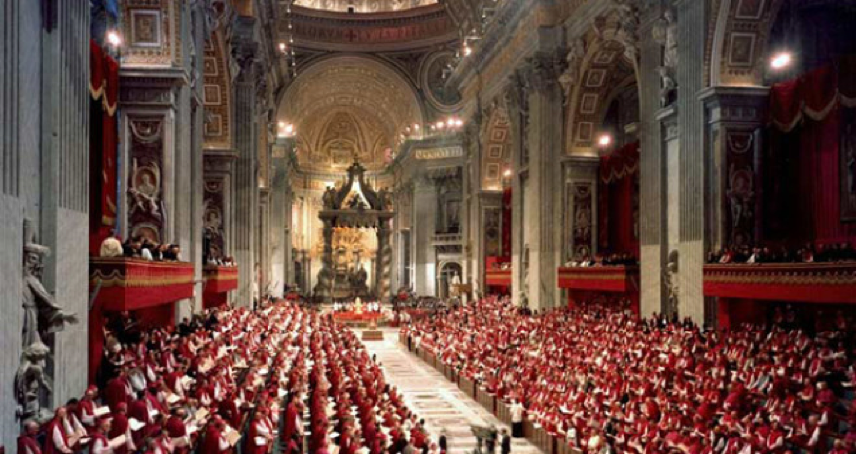
Vatican II and You
Vatican II had a big impact on ecumenism. But what was it about, what did it do and what effect did it have on you? Come and have your say.

The Churches Together Autumn Forum
7:45pm for 8pm Thursday 18th October
City Church, Unity Works,
Lyon Way, AL4 0LB

____________________
Churches Together in St Albans
ctstalbans.org.uk

